**BNV COLLEGE OF TEACHER EDUCATION**

**INTERNATIONAL PEACE DAY CELEBRATION**

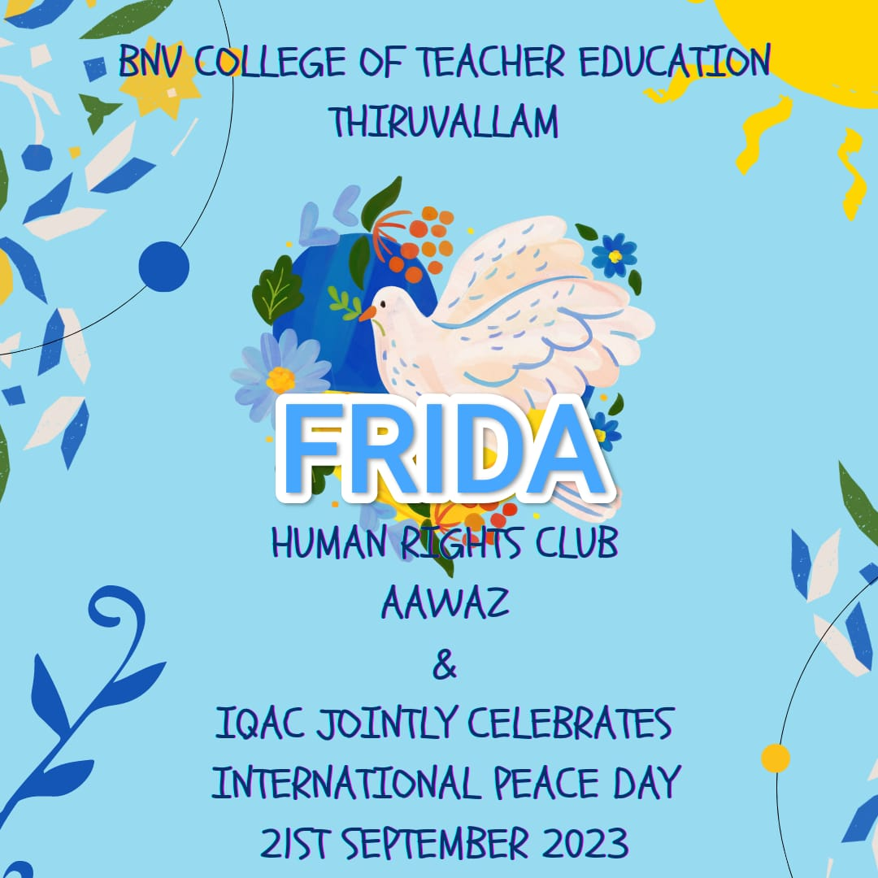

On September 21, 2023, the Human Rights Forum Aawaz of BNV College of Teacher Education organized a signature collection campaign in connection with the celebration of International Peace Day. The event was themed "Actions for Peace: Our Ambition for Global Goals," and it was inaugurated by Dr. G. Valsala, the Principal of BNVCTE. Faculty members and students actively participated in the program, contributing to the collective effort for peace.

